IAM Created CLI Command
~ $ vi trust-policy.json
Policy:
{
"Version": "2012-10-17",
"Statement": [
{
"Effect": "Allow",
"Principal": {
"Service": "lambda.amazonaws.com"
},
"Action": "sts:AssumeRole"
}
]
}
~ $ aws iam create-role \
--role-name LambdaExecutionRole \
--assume-role-policy-document file://trust-policy.json
~$ aws iam attach-role-policy \
--role-name LambdaExecutionRole \
--policy-arn arn:aws:iam::aws:policy/service-role/AWSLambdaBasicExecutionRole

~$ aws iam get-role --role-name LambdaExecutionRole
Output:
{
"Role": {
("Path": "/",
"RoleName": "LambdaExecutionRole",
"RoleId": "AROA3NF6C4YEYGV3ZR3QA",
"Arn": "arn:aws:iam::784230180361:role/LambdaExecutionRole",
"CreateDate": "2026-09-09T07:10:36+00:00",
"AssumeRolePolicyDocument": {
"Version": "2012-10-17",
"Statement": [
{
"Effect": "Allow",
"Principal": {
"Service": "lambda.amazonaws.com"
},
"Action": "sts:AssumeRole"
}
]
},
"MaxSessionDuration": 3600,
"RoleLastUsed": {
"LastUsedDate": "2026-09-09T07:26:06+00:00",
"Region": "us-east-1"
}
}
}
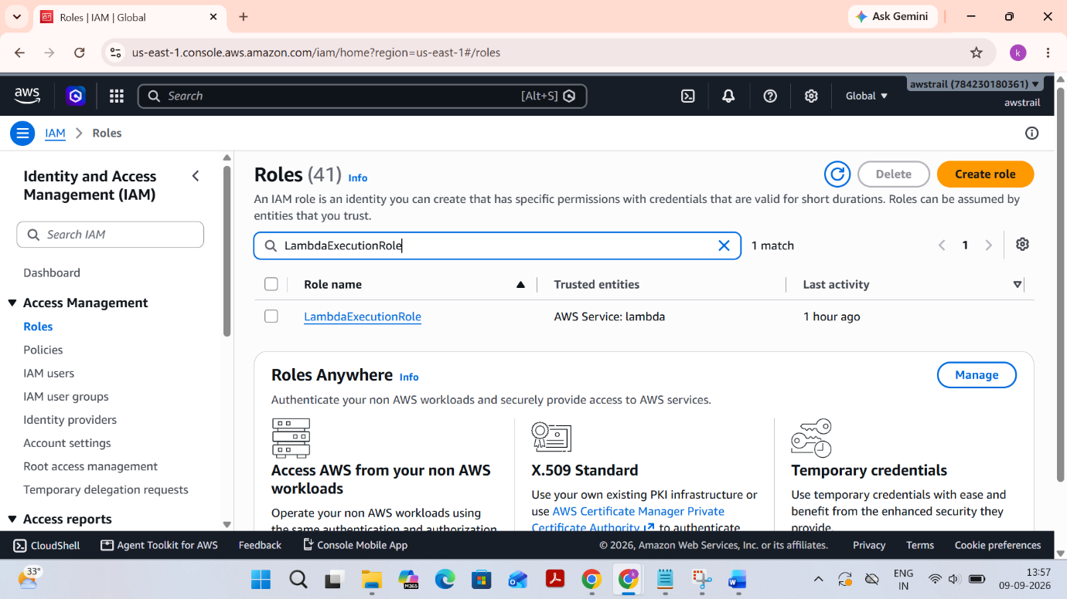
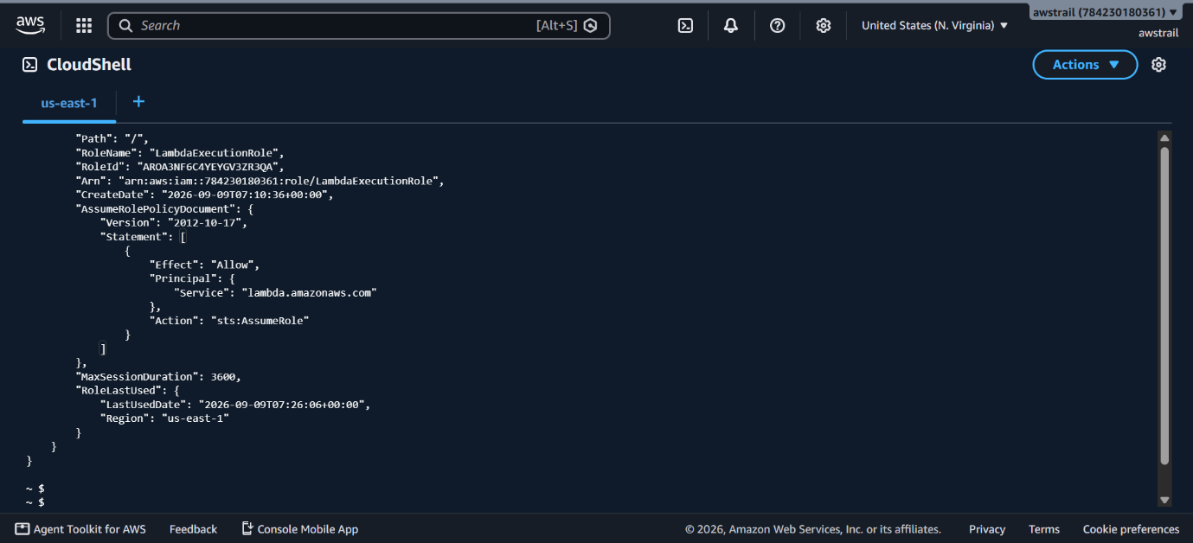

Lambda Created CLI Command

~$ aws lambda create-function \
--function-name MyFirstLambda \
--runtime python3.12 \
--role
arn:aws:iam::784230180361:role/LambdaExecutionRole \
--handler lambda_function.lambda_handler \
--zip-file fileb://function.zip \
--region us-east-1
~$ aws lambda get-function --function-name MyFirstLambda --region us-east-1
{
"Configuration": {
"FunctionName": "MyFirstLambda",
"FunctionArn": "arn:aws:lambda:us-east-1:784230180361:function:MyFirstLambda",
"Runtime": "python3.12",
"Role": "arn:aws:iam::784230180361:role/LambdaExecutionRole",
"Handler": "lambda_function.lambda_handler",
"CodeSize": 344,
"Description": "",
"Timeout": 3,
"MemorySize": 128,
"LastModified": "2026-09-09T07:23:47.480+0000",
"CodeSha256": "0HLrdaZBLoPcSoFethsH8pUpjKy5SKXnBhPwKxVWAnk=",
"Version": "$LATEST",
"TracingConfig": {
"Mode": "PassThrough"
},
"RevisionId": "4cdcceb9-9596-4001-937c-7e6c02c8a6f2",
"State": "Active",
"LastUpdateStatus": "Successful",
"PackageType": "Zip",
"Architectures": [
"x86_64"
],
"EphemeralStorage": {
"Size": 512
},
"SnapStart": {
"ApplyOn": "None",
"OptimizationStatus": "Off"
},
"RuntimeVersionConfig": {
"RuntimeVersionArn": "arn:aws:lambda:us-east-1::runtime:c1ab740f3656a72d7917665a940f8634df245489445f5a660de5a634d06c5433"
},
"LoggingConfig": {
"LogFormat": "Text",
"LogGroup": "/aws/lambda/MyFirstLambda"
}
},
"Code": {
"RepositoryType": "S3",
